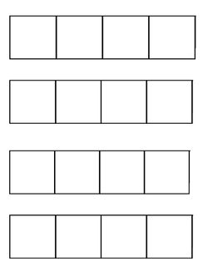 

 

Word Chains with 4 Sounds