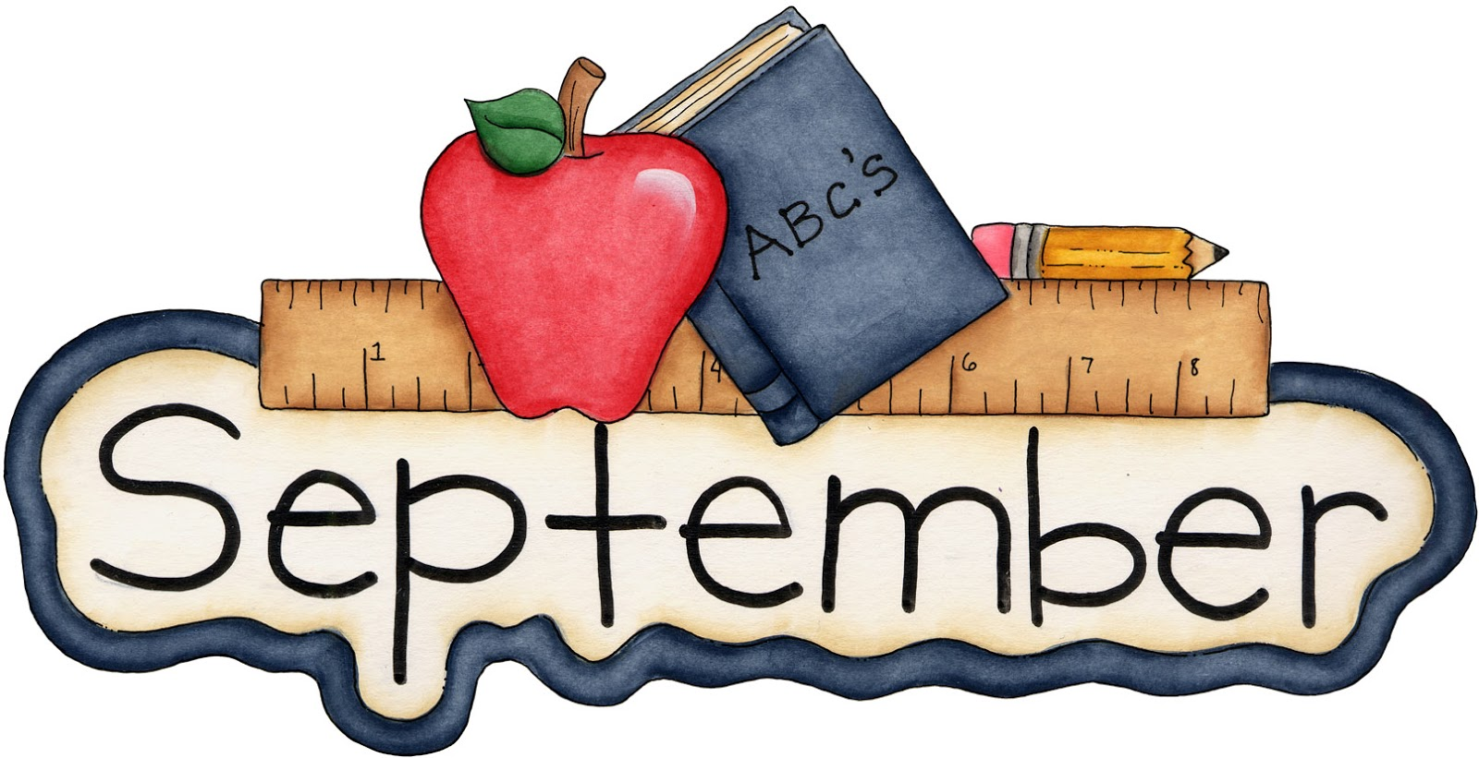

Reading Homework From Mrs. Araujo

If you have access to the Internet, please go to: www.mrsjudyaraujo.com.

There is a PreK-2 LiveBinder on the home page. Please help your child do the activities in the Live Binder. When you hit the yellow tab, light green tabs appear at the bottom of the menu for more activities.

Phonemic and Phonological Awareness activities tab. Having mastery of manipulating oral sounds is the foundation of reading.

Letter Identification/Sounds tab. In September, we are working on mastering letter names and letter sounds, including the 5 short vowel sounds and 2 sounds of c and g.

Rhyming tab.

Beginning/Ending Sounds tab.

On my website under Parents, please visit:

Phonemic Awareness for PreK, K, and 1 and do those oral activities with your child.

Advice for PreK and K Parents/Letter Sound Teaching Order and print out the Fundations workbook which is on the top of that page. This is what your child is learning in school. You can reinforce these skills at home. Letters are always formed from the top down.

On my website under Teachers, please visit:

Free Literacy Assessments. Try the Reading Readiness activities with your child, especially the DIBELS. Hit Download Testing Materials link on the right, then hit DIBELS 6th on left, and grade 1. Work on letter naming in a minute, phoneme segmentation in a minute ~ you say the word, child breaks word into individual sounds ~ as many as he can in 1 minute, nonsense word fluency ~ how many nonsense words can he/she read in 1 minute? You don’t have to follow the directions exactly, but see what your child can do. These are essential prereading skills.

