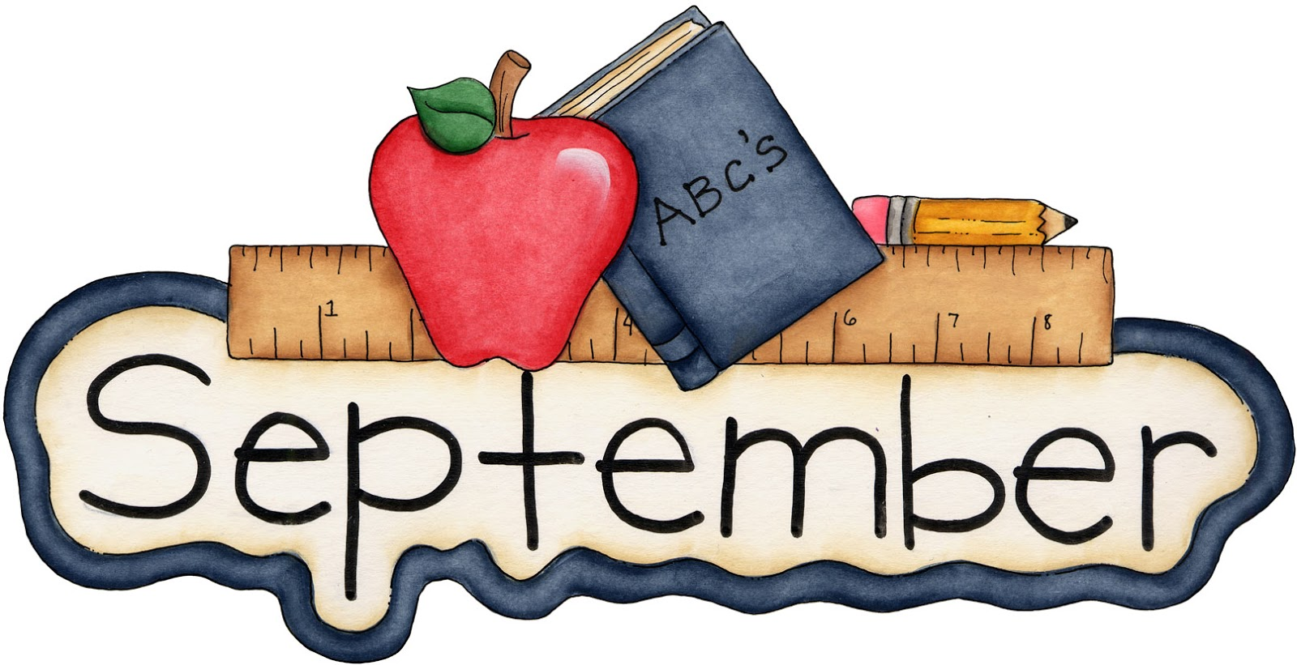

Grade 2 Homework from Mrs. Araujo

**Homework is to reread the packet of papers, finish/fix work as needed, explain to an adult what you learned this month.**

We always reread for fluency and accuracy.

All of my monthly goals are posted on my website (www.mrsjudyaraujo.com) under Mrs. Araujo’s Scope & Sequence. If you have access to the Internet at home, please visit my website and have your child do the activities on the LiveBinders under the Student menu. Have your child move through each tab. There’s so much to do on there!

IN SEPTEMBER, THE STUDENT WILL BE ABLE TO:

- Master the 37 rimes for both reading and spelling. You can find them on my website under the Spelling menu.
- Demonstrate evidence of short vowel knowledge in cvc, ccvc, cvcc words and magic e words when reading and writing.
- Review FLOSS rule. Read and reread corresponding Orton-Gillingham stories. Define and apply FLOSS rule. (f, l, s double when at the end of short vowel words)
- Divide words with vc/cv, vc/ccv, vc/cvce syllable types.
- Demonstrate knowledge 1:1 on preprimer, primer, first grade sight words. These are on my website under the Parent menu.
- Find the main idea of short paragraphs ~ packet.
- Make a movie in mind when reading pictureless texts.
- Read Level I books, reviewing FAB4: Predict, Clarify, Question, Summarize.
- Establish a list of rules/consequences as a group.

