Five-Finger Retell

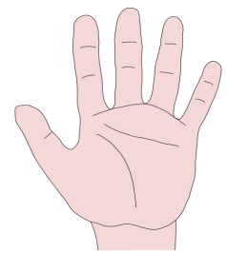

1.Characters

2. Setting

3. Problem

4. Events

5. Ending

Retell the story using your thumb (1. Characters)
index finger (2. Setting)
tall finger (3. Problem)
ring finger (4. Events)
little finger (5. Ending)

Five-Finger Retell

1.Characters

2. Setting

3. Problem

4. Events

5. Ending

Retell the story using your thumb (1. Characters)
index finger (2. Setting)
tall finger (3. Problem)
ring finger (4. Events)
little finger (5. Ending)

Five-Finger Retell

1.Characters

2. Setting

3. Problem

4. Events

5. Ending

Retell the story using your thumb (1. Characters)
index finger (2. Setting)
tall finger (3. Problem)
ring finger (4. Events)
little finger (5. Ending)

Five-Finger Retell

1.Characters

2. Setting

3. Problem

4. Events

5. Ending

Retell the story using your thumb (1. Characters)
index finger (2. Setting)
tall finger (3. Problem)
ring finger (4. Events)
little finger (5. Ending)

